Software Requirements
Specification

Electronic Medical Information System
(EMIS)
by

Jeff McKinney

Table of Contents

Table of Figures....................................................................................................................................... 3
List of Tables............................................................................................................................................ 4
Use Case Diagram Description...............................................................................................................5
Class Diagram Description...................................................................................................................17

Table of Figures

Figure 1: Use Case Diagram of EMIS.......................................................................................................6
Figure 2: Class Diagram..........................................................................................................................17

List of Tables

Table 1: Use Case 1 – Make Appointment.................................................................................................7
Table 2: Use Case 2 – Enter Information...................................................................................................7
Table 3: Use Case 3 –Appointment Questionnaire....................................................................................8
Table 4: Use Case 4 –Request Medical Records........................................................................................9
Table 5: Use Case 5 –Cancel Appointment................................................................................................9
Table 6: Use Case 6 –Reschedule Appointment......................................................................................10
Table 7: Use Case 7 –Current Medical Conditions..................................................................................10
Table 8: Use Case 8 –Diagnoses..............................................................................................................11
Table 9: Use Case 9 –Referral..................................................................................................................12
Table 10: Use Case 10 –Pay.....................................................................................................................12
Table 11: Use Case 11–Issue Records......................................................................................................13
Table 12: Use Case 12 –Appointment Reminder.....................................................................................14
Table 13: Use Case 13 –System Save......................................................................................................14
Table 14: Use Case 14 –System Restart...................................................................................................15
Table 15: Use Case 15 –System Restore..................................................................................................16

Use Case Diagram Description

The use case diagram is like a graphical table of contents that presents the system’s
behavior in respect to the users. The system’s use case diagram (see Figure 1 pg. 6)
presents:
▪ the system’s actors. Here the actors (patient, doctor, nurse, receptionist, system admin, and insurance agent) are humans. Time is the only non-human actor.

▪ a list of use cases (represented as ovals). There are a total of 14 use cases.

▪ relationships (represented as straight lines). Those that show an association relationship between the actors and use cases (such as the patient actor, who shows an association with the 'make an appointment' use case) are drawn with a straight line connecting them. Another actor can also be
associated with the same use case indicating those parties are involved in the use case.

This particular use case diagram depicts the Electronic Medical Information System, or EMIS. The EMIS
is designed to move the clinics paper patient records to a secure electronic storage system. It is also able to store appointments, doctor's diagnoses, referrals, and results.

Figure 1: Use Case diagram of EMIS

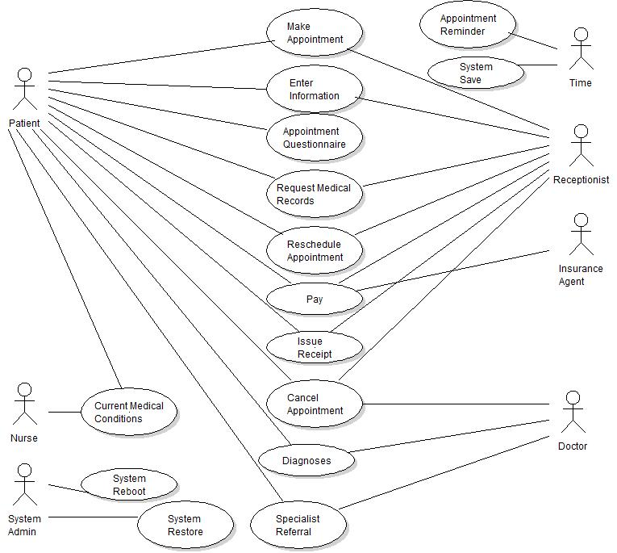

Table 1: Use Case 1 – Make Appointment

Name: Make Appointment | ID: UC1
Brief Description:

This use case describes how a patient requests an appointment.

Preconditions:

this is not the patients first visit

Basic Flow:

The use case starts out with the patient requesting an appointment, over the phone, with the
receptionist. The receptionist checks the calendar for available time slots and provides the options to
the patient. The patient then selects from the time slots available.

Alternate Flow:

New Patient
If the patient is new he/she will have to fill out additional information at the clinic before scheduling a regular appointment.

Table 2: Use Case 2 – Enter Information

Name: Enter Information | ID: UC2
Brief Description:

This use case describes how a information is entered by the patient or for the patient

Preconditions:

none

Basic Flow:

The patient uses the EMIS to enter his/hew own information to include
Name:
Age:
Sex:
Address:
Social Security:
Insurance:
Emergency Contact:

Alternate Flow:

The receptionist instead enters the information on the patients behalf

Table 3: Use Case 3 – Appointment Questionnaire

Name: Appointment Questionnaire | ID: UC3
Brief Description:

This use case describes how an actor fills out the appointment questionnaire before being called in for
their appointment.

Preconditions:

The patient has an appointment scheduled for the day.

Basic Flow:

Once the patient arrives at the clinic he/she fills out the questionnaire. The questionnaire asks questions pertaining to

Name:
Age:
Sex:
Social Security:
Reason for Visit:
Current Medications:
Allergies:

Alternate Flow:

none

Table 4: Use Case 4 – Request Medical Records

Name: Request Medical Records | ID: UC4
Brief Description:

This use case describes how an actor requests medical records for personal use and transfer.

Preconditions:

The patient is verified through HIPA regulations and is a current patient under the clinics care.

Basic Flow:

The use case starts out with the patient requests his/her records through the EMIS system. Once verified the records are released to the patient for his/her purposes.

Alternate Flow:

none

Table 5: Use Case 5 – Cancel Appointment

Name: Cancel Appointment | ID: UC5
Brief Description:

This use case describes how an actor cancels an appointment.

Preconditions:

the patient has an appointment at the clinic

Basic Flow:

The use case starts out when the patient requests to cancel an appointment. The patient has the option to reschedule the appointment. If the patient elects to reschedule UC1 takes effect.

Alternate Flow:

If the patient fails to cancel with sufficient notice, 24 hours before, a cancellation fee will apply.

If the doctor is the one to cancel the appointment then the receptionist will be required to contact the patient to set up another appointment. In which case UC1 takes effect.

Table 6: Use Case 6 – Reschedule Appointment

Name: Reschedule Appointment | ID: UC6
Brief Description:

This use case describes how an actor reschedules an appointment.

Preconditions:

the patient has an appointment

Basic Flow:

The patient will call the clinics receptionist and ask to reschedule their appointment. The receptionist
will check the hospital calendar and offer available times. Refer to UC1.
.

Alternate Flow:

If the patient does not give sufficient notice there will be a late fee charged.

Table 7: Use Case 7 – Current Medical Conditions

Name: Current Medical Conditions | ID: UC7
Brief Description:

The nurse calls the patient to the back to evaluate current medical conditions

Preconditions:

The patient has an appointment and has completed the pre-appointment questionnaire.

Basic Flow:

The nurse evaluates the patients current medical conditions by various tests and questions.

Test include:
Blood Pressure
Heart Rate
Eyes, nose, and throat check
Listen to lungs with a stethoscope
Weight
Height

Questions include:
What is wrong?
When it occurred?
How often?
Is this an on going problem?
History of illness.

Alternate Flow:

none

Table 8: Use Case 8 – Diagnoses

Name: Diagnoses | ID: UC8
Brief Description:

This use case pertains to the diagnoses of the patient by the doctor

Preconditions:

the doctor has come to a diagnoses about the patients aliment

Basic Flow:

Once the doctor sees the patient and is able to come to a diagnoses, the doctor then enters his diagnoses into the EMIS. Once entered the EMIS will go into the patients permanent record file on the EMIS.

Alternate Flow:

If the doctor can not come up with a diagnoses, the doctor will refer a patient to a specialist. See use case 8.

Table 9: Use Case 9 – Referral

Name: Referral | ID: UC9
Brief Description:

This use case pertains to the referral of a patient to another doctor, including specialist.

Preconditions:

the patient has received an exam by a doctor of the clinic.

Basic Flow:

If the doctor comes up with a diagnoses that can not be treated by the clinics resources or if the doctor can not come up with a diagnoses at all, the doctor will refer the patient to a specialist. The doctor will
send the referral to the EMIS and will be forwarded to the proper entity.

Alternate Flow:

none

Table 10: Use Case 10 – Pay

Name: Pay | ID: UC10
Brief Description:

This use case pertains to the payment method of services

Preconditions:

the patient has received clinic services and is covered through clinic supported insurance

Basic Flow:

The receptionist asks the patient to provide insurance identification and is requested to pay the required copay.

Alternate Flow:

If the patient is not covered by insurance then the full fee for the office visit and treatment will be assessed.

If the patient is covered by an insurance that is not supported by the clinic then the patient will be charged in full for services and issued a form to take to their insurance company detailing the visits procedures and costs.

Table 11: Use Case 11 – Issue Receipt

Name: Issue Receipt | ID: UC11
Brief Description:

Issue a receipt for services performed in the clinic

Preconditions:

The patient paid for services performed at the clinic

Basic Flow:

After the patient has received clinical services and has paid for said services he/she will be issued an itemized receipt.

Alternate Flow:

If the receipt paper supply is depleted maintenance will replenish the supply

Table 12: Use Case 12 – Appointment Reminder

Name: Appointment Reminder | ID: UC12
Brief Description:

This use case pertains to the automatic appointment reminder system

Preconditions:

the patient has an appointment with in the next 24 hours.

Basic Flow:

When there are 24 hours left before the patients next scheduled appointment. The EMIS will send out an automatic reminder by the patients preferred contact method.
These include one or more of the following:
E-Mail
Telephone Call
Text Message
Carrier Pigeon

Alternate Flow:

none

Table 13: Use Case 13 – System Save

Name: Pay | ID: UC13
Brief Description:

This use case pertains to the system save feature provided by the EMIS

Preconditions:

the EMIS is up and running as normal

Basic Flow:

Every 4 hours the EMIS will save its current version to an off site data back up center. This time frame
can be changed by the system administrator

Alternate Flow:

none

Table 14: Use Case 14 – System Restart

Name: System Restart | ID: UC14
Brief Description:

This use case pertains to the system restart. The system administrator can use the restart function to attempt to fix any problems with the EMIS.

Preconditions:

none

Basic Flow:

The system administrator uses the restart function to fix a problem with the EMIS. The EMIS saves all data it can locally and sends a special update to the off site backup center, out side of the usual UC13.

Alternate Flow:

If the system restart is unsuccessful the system admin will use UC15.

Table 15: Use Case 15 – System Restore

Name: System Restore | ID: UC15
Brief Description:

This use case pertains to the System Restore feature for the EMIS

Preconditions:

none

Basic Flow:

The system administrator selects the system restore option when other avenues of approach have failed. The EMIS retrieves its back up from the off site data storage center and reboots with the last working save.

Alternate Flow:

none

Class Diagram Description

The class diagram shows how the actors interact with the system and how they are related. In this diagram the person class is the root class for any persons that interact with the clinic. This includes
patients, doctors, nurses, and support staff. Each person is associated with the records class. The records class holds all information regarding appointments, referrals, prescriptions, diagnoses, calendar entries, and balances due.

